WEEK – 2

PL/SQL Programming

Exercise 1: Control Structures

DECLARE

grade CHAR(1) := '&Enter_Grade';

BEGIN

CASE grade

WHEN 'A' THEN DBMS_OUTPUT.PUT_LINE('Excellent');

WHEN 'B' THEN DBMS_OUTPUT.PUT_LINE('Good');

WHEN 'C' THEN DBMS_OUTPUT.PUT_LINE('Average');

WHEN 'D' THEN DBMS_OUTPUT.PUT_LINE('Below Average');

WHEN 'F' THEN DBMS_OUTPUT.PUT_LINE('Fail');

ELSE DBMS_OUTPUT.PUT_LINE('Invalid grade');

END CASE;

END;

/

OUTPUT :

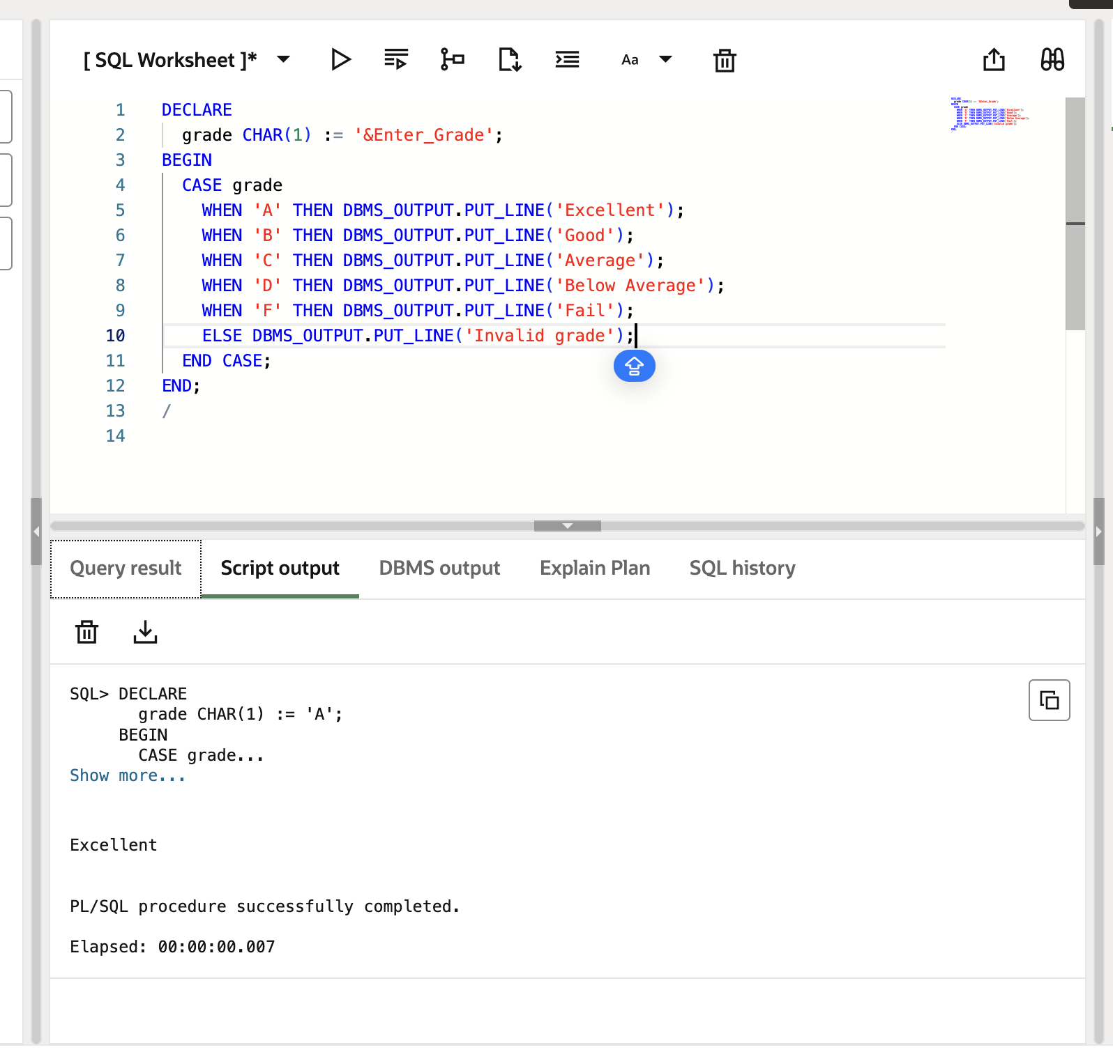

Exercise 3: Stored Procedures

DECLARE

pnum NUMBER := 5;

psquare NUMBER;

BEGIN

psquare := pnum * pnum;

DBMS_OUTPUT.PUT_LINE('Square of ' || pnum || ' is: ' || psquare);

END;

/

OUTPUT :

